Physics 3A/3B Score /20 Name _________________

Lab Validation - Spectra

- Choose one or two from the following classifications of spectral types to match each picture below. For each also choose an appropriate source that might be responsible for the spectrum shown. (NOTE - spectra may be a combination of two classifications, but you should only choose two if you are certain they both apply).

Classification Source

Line Emission An incandescent light bulb (filament)
Line absorption The solar spectrum
Band Emission White light passing through liquid chlorophyll Band Absorption Hydrogen discharge tube
Continuos Emission Fluorescent tube
a)

Classification/s ______________________________________

Source ____________________________________________
(2 marks)
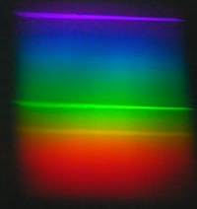
b)

Classification/s _____________________________________

Source __________________________________________

(2 marks)
c)
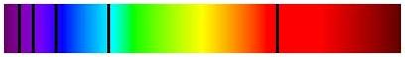

Classification/s __________________________________________

Source ________________________________________________
(2 marks)
d)

Classification/s __________________________________________

Source ________________________________________________
(2 marks)

e)


Classification/s __________________________________________

Source ________________________________________________
(2 marks)

- Explain why the spectrum observed when looking at the hot sun through a spectrometer, and the spectrum observed whilst looking at a white HOT solid are not the same.

(4 marks)
- Describe in dot point form the production of the spectrum from a fluorescent tube

(6 marks)

